## **Master Settings**

## **1. Contract Type**

### **Description:**

This section allows users to manage different contract types within the system. Users can add new contract types using a form.

### **Form Fields:**

* Contract Type: Text input field
* Save: Button to save the entered contract type

## **Reference screenshot**

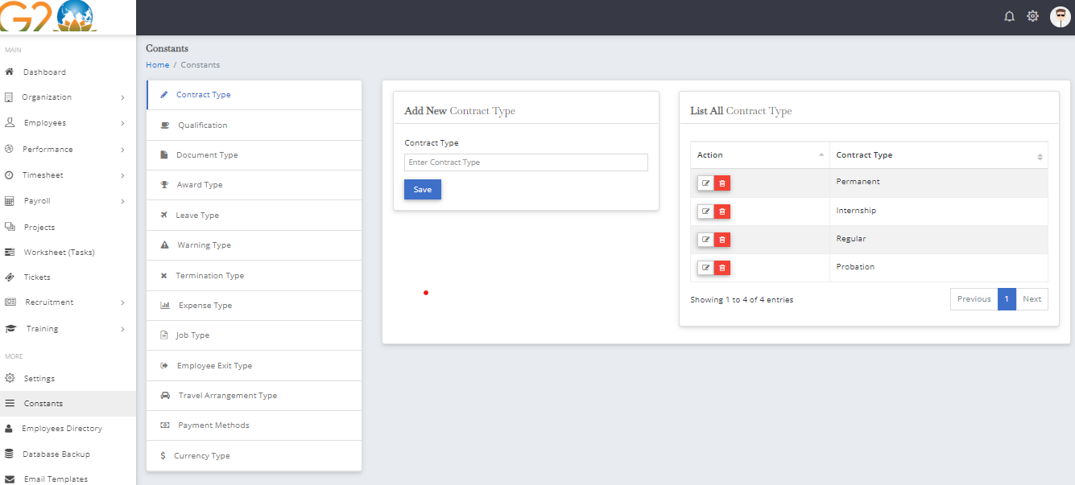

## **2.Qualification**

### **Description:**

This section facilitates the addition of education levels to the system. Users can input various education levels using a dedicated form.

### **Form Fields:**

* Education Level: Text input field
* Save: Button to save the entered education level (e.g., Graduate, Post Graduate, Associate Degree)

## **Reference screenshot**

## 

## 

## 

## **3.Document Type**

### **Description:**

This section is designed for managing different document types. Users can add new document types using a form.

### **Form Fields:**

* Document Type: Text input field
* Save: Button to save the entered document type (e.g., Visa, Passport, Driving License)

## **Reference screenshot**

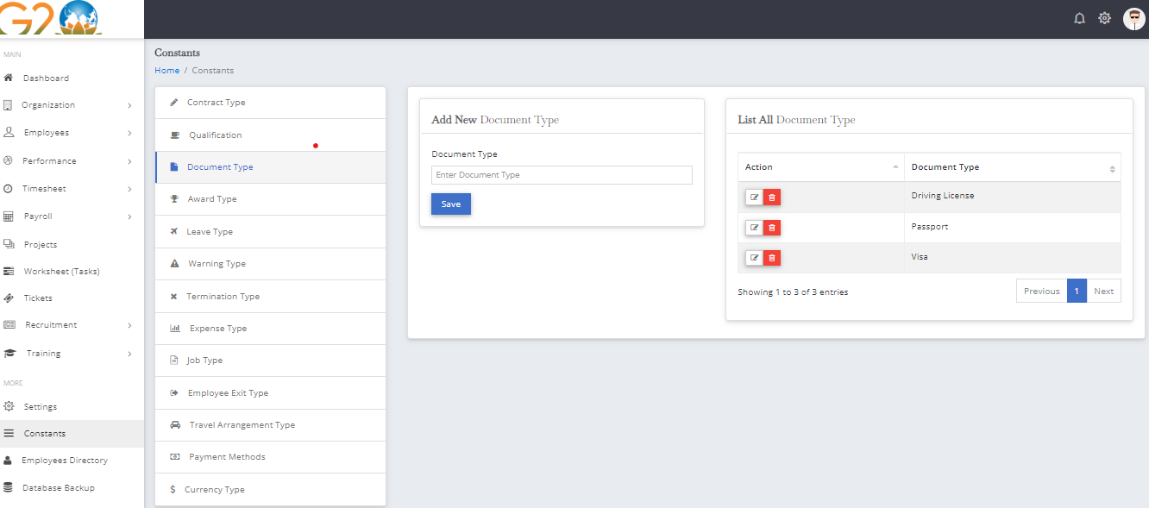

## **4.Award Type**

### **Description:**

This section allows users to add new award types to the system. Users can input various award types using a form.

### **Form Fields:**

* Award Type: Text input field
* Save: Button to save the entered award type (e.g., Performance of the Year, Employee of the Year, Hard Worker Award)

## **Reference screenshot**

## 

## 

## **5.Leave Type**

### **Description:**

This section is dedicated to managing different types of leaves within the system. Users can add new leave types using a form.

### **Form Fields:**

* Select Employee: Select input for choosing an employee
* Leave Type: Text input field
* Days per Year: Text input field
* Save: Button to save the entered leave type information

## **Reference screenshot**

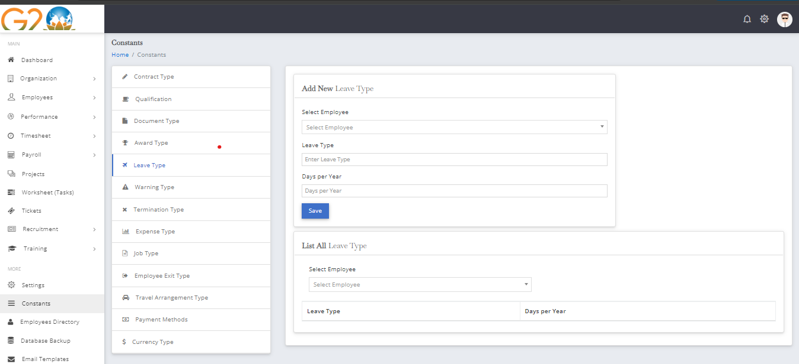

## 

## **6.Warning Type**

### **Description:**

This section allows users to add new warning types to the system. Users can input various warning types using a form.

### **Form Fields:**

* Warning Type: Text input field
* Save: Button to save the entered warning type

## **Reference screenshot**

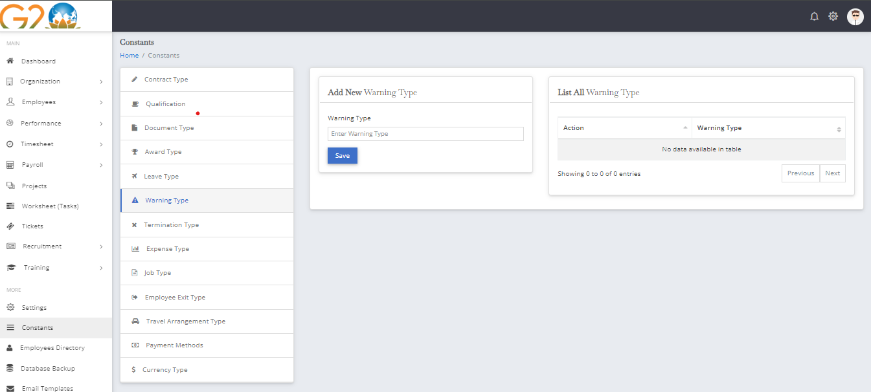

## **7.Termination Type**

### **Description:**

This section is designed for managing different termination types. Users can add new termination types using a form.

### **Form Fields:**

* Termination Type: Text input field
* Save: Button to save the entered termination type (e.g., Layoff, Damaging Company Property, Insubordination)

## **Reference screenshot**

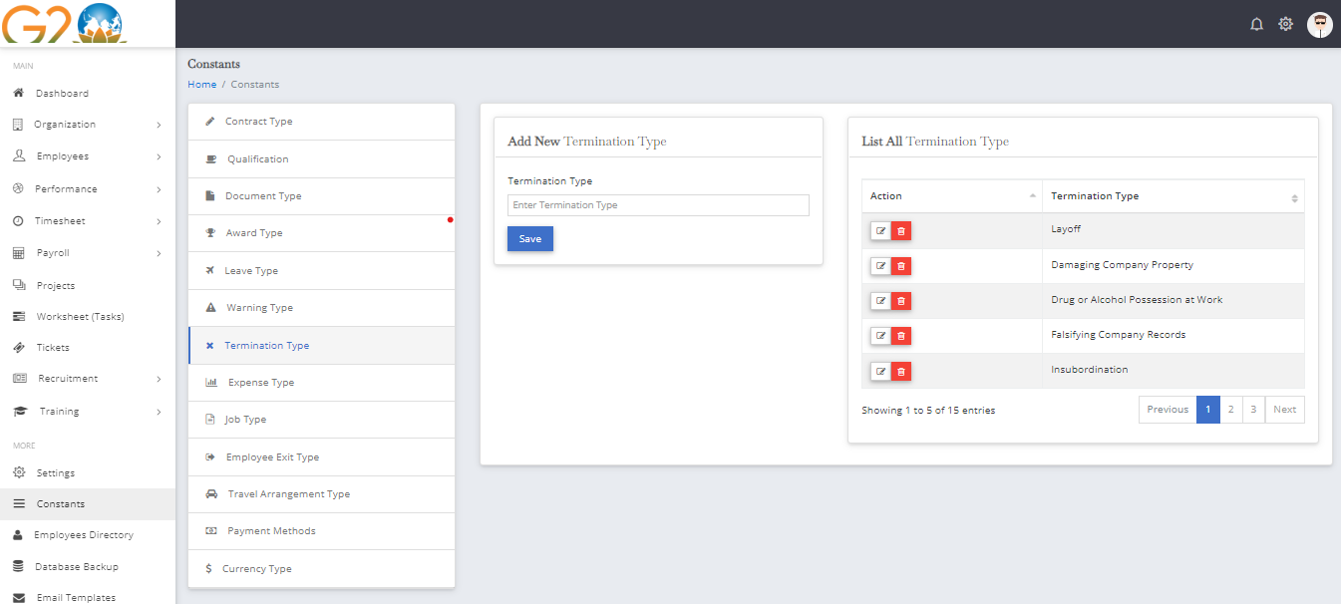

## **8.Expense Type**

### **Description:**

This section facilitates the addition of various expense types to the system. Users can input new expense types using a form.

### **Form Fields:**

* Expense Type: Text input field
* Save: Button to save the entered expense type (e.g., Wages, Supplies, Utilities)

## **Reference screenshot**

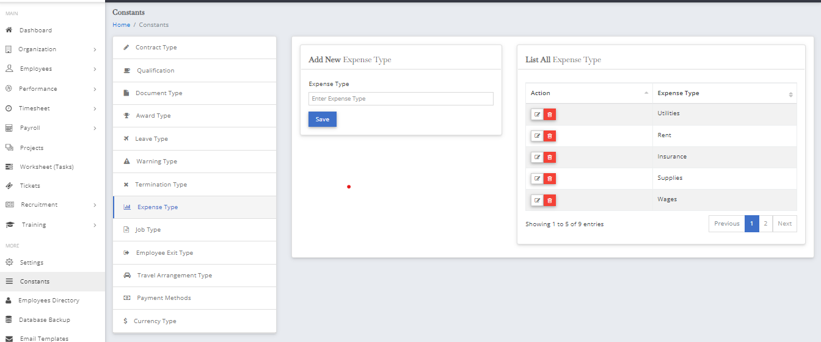

## **9.Job Type**

### **Description:**

This section allows users to manage different job types within the system. Users can add new job types using a form.

### **Form Fields:**

* Job Type: Text input field
* Save: Button to save the entered job type (e.g., Full Time, Part Time, Intern)

## **Reference screenshot**

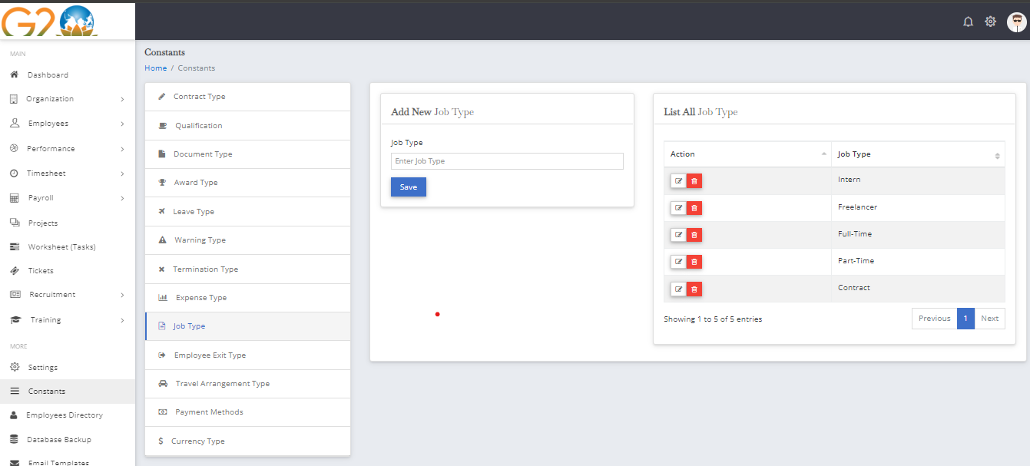

## **10.Employee Exit Type**

### **Description:**

This section is designed for managing different types of employee exits. Users can add new exit types using a form.

### **Form Fields:**

* Employee Exit Type: Text input field
* Save: Button to save the entered exit type (e.g., Resignation, Retirement, Dismissal)

## **Reference screenshot**

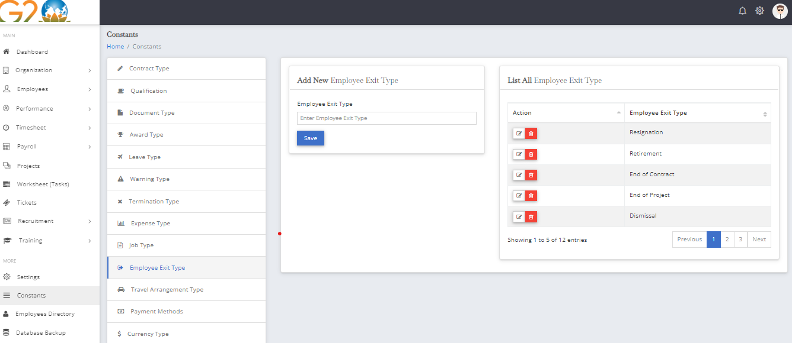

## 

## **11.Travel Arrangement Type**

### **Description:**

This section allows users to add new travel arrangement types to the system. Users can input various travel arrangement types using a dedicated form.

### **Form Fields:**

* Travel Arrangement Type: Text input field
* Save: Button to save the entered travel arrangement type (e.g., AirBnB, Motel, Guest House)

## **Reference screenshot**

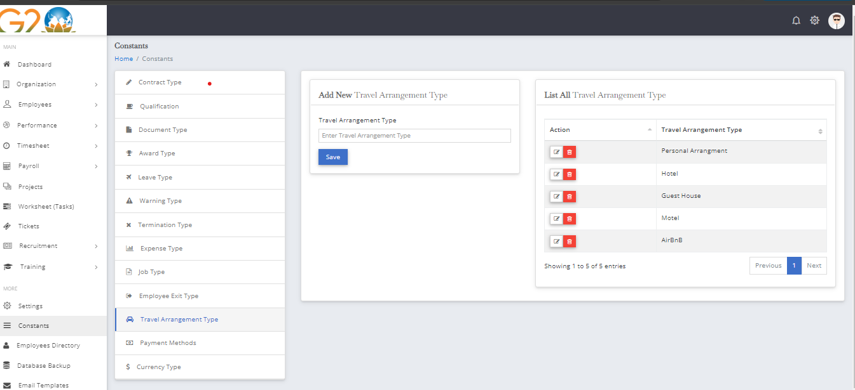

## **12.Payment Method**

### **Description:**

This section is designed for managing different payment methods. Users can add new payment methods using a form.

### **Form Fields:**

* Payment Method: Text input field
* Save: Button to save the entered payment method (e.g., Cash, Bank)

## **Reference screenshot**

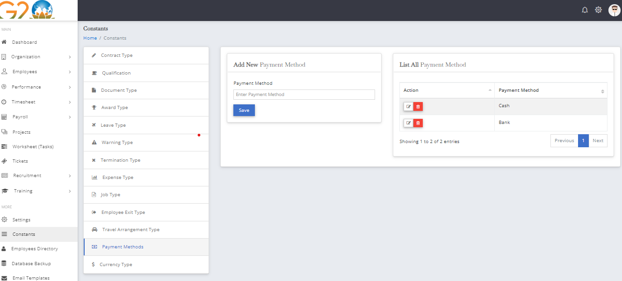

## **13.Currency Type**

### **Description:**

This section facilitates the addition of various currency types to the system. Users can input new currency types using a form.

### **Form Fields:**

* Currency Name: Text input field
* Currency Code: Text input field
* Currency Symbol: Text input field
* Save: Button to save the entered currency type (e.g., Rupee, Dollar)

## **Reference screenshot**

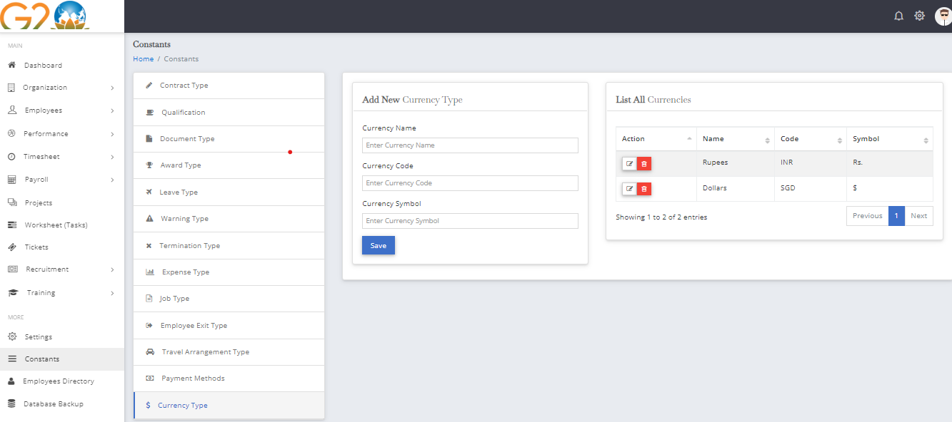

## **14.Animation Effects**

### **Description:**

This section allows users to set animations for the top menu and modal dialogs. Users can configure animations through a form.

### **Form Fields:**

* Top Menu Animation: Select input field
* Modal Dialog Animation: Select input field
* Save: Button to save the selected animation effects

## **Reference screenshot**

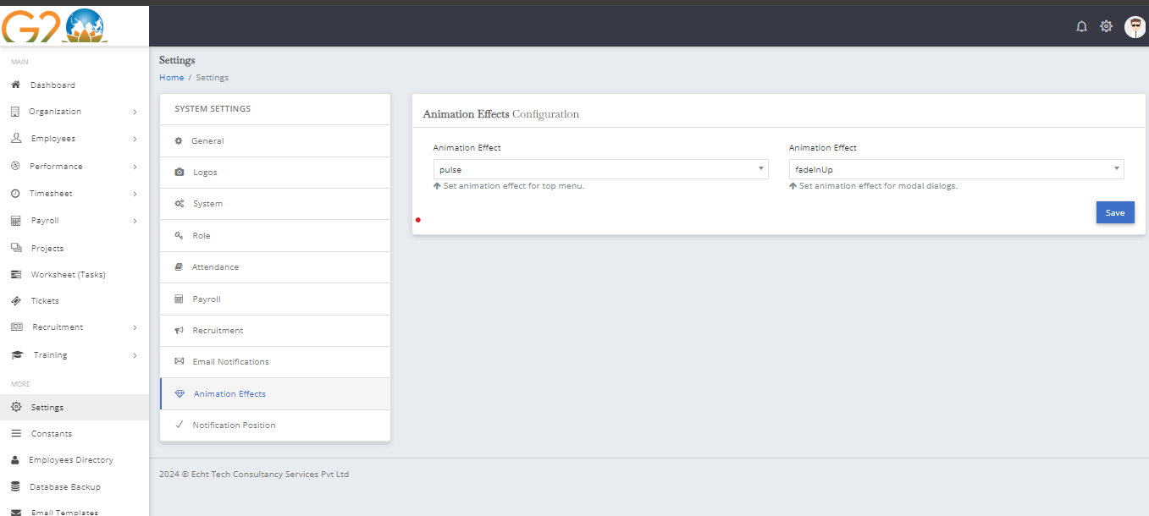

## **15.General Configuration**

### **Description:**

This section is for general configuration settings. Users can input company information and general details using a form.

### **Form Fields:**

* Company Name: Text input field
* Address: Text input field
* Contact Person Name: Text input field
* Address Line 2: Text input field
* Email: Text input field
* State: Text input field
* City: Text input field
* Pincode: Text input field
* Country: Text input field
* Phone: Text input field
* Save: Button to save the entered general configuration details

## **Reference screenshot**

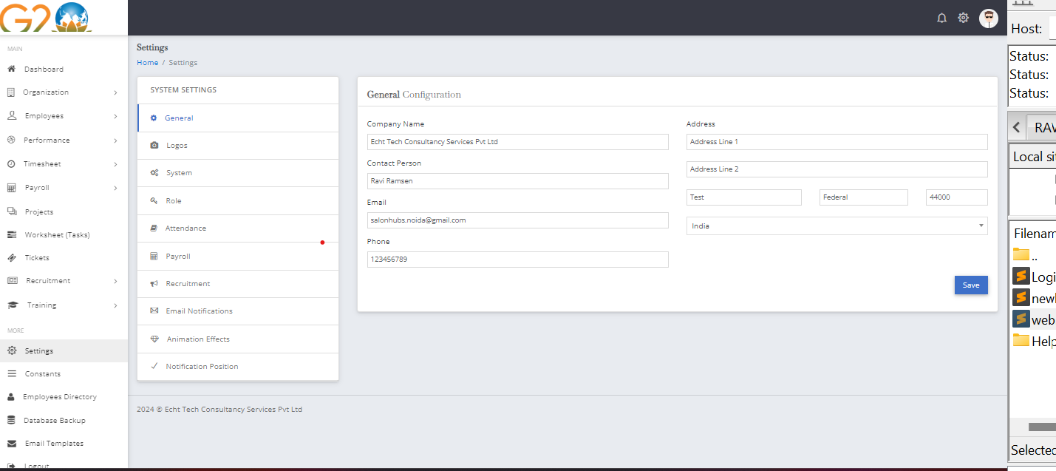

## **16.System Configurations**

### **Description:**

This section allows users to configure various system settings. Users can customize application name, date format, default currency, footer text, and more.

### **Form Fields:**

* Application Name: Text input field
* Date Format: Select input field with multiple date format options
* Default Currency: Select input field for currency selection
* Default Currency Symbol/Code: Select input field for currency symbol or code
* Footer Text: Text input field
* Currency Position: Select input field
* Enable Currency Year on Footer: Toggle switch
* Save: Button to save the configured system settings

## **Reference screenshot**

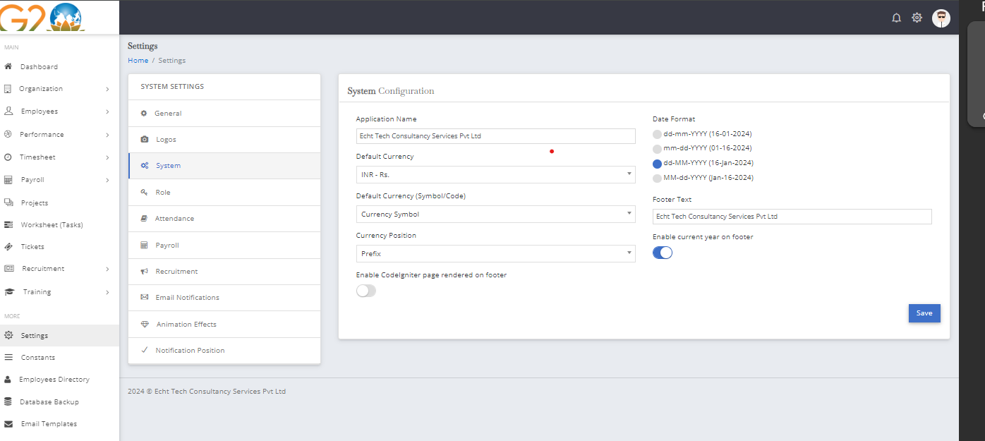

## 

## **17.Attendance Configuration**

### **Description:**

This section is for configuring attendance settings, including enabling clock-in buttons on the header and enabling clock-in and clock-out functionality.

### **Form Fields:**

* Enable Clock-in Button on Header: Toggle switch
* Enable Clock-in and Clock-out: Toggle switch
* Save: Button to save the attendance configuration

## **Reference screenshot**

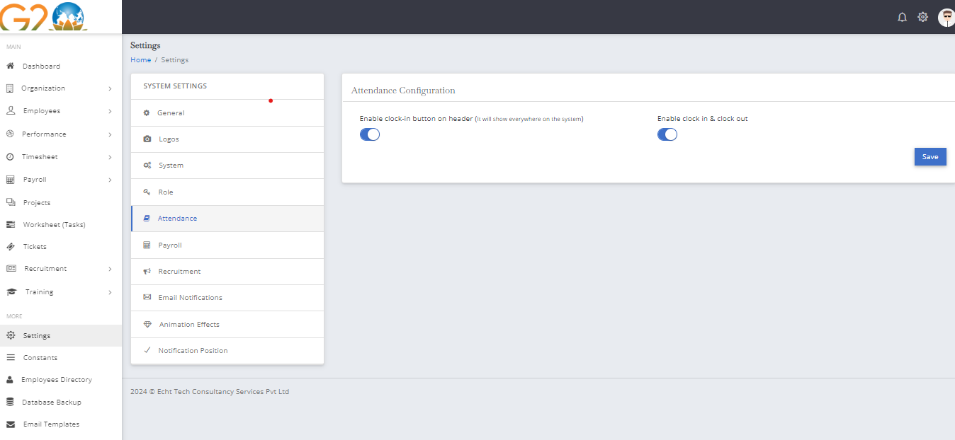

## **18.Email Notification**

### **Description:**

This section allows users to enable or disable email notifications through a toggle switch.

### **Form Fields:**

* Enable Email Notifications: Toggle switch
* Save: Button to save the email notification settings

## **Reference screenshot**

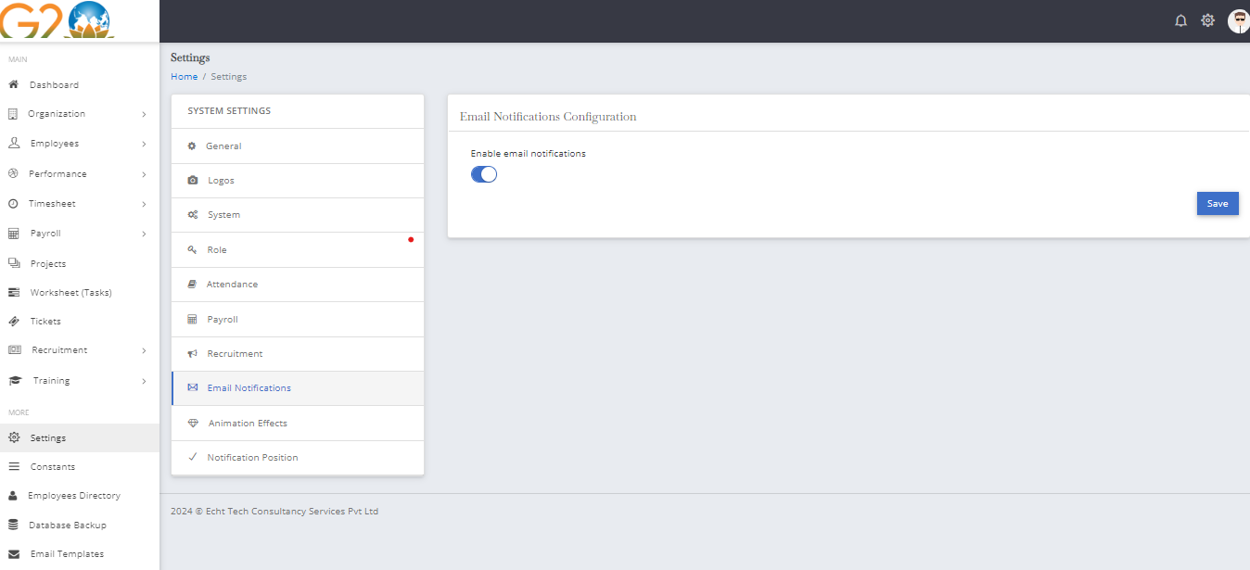

## **19.Notification Position**

### **Description:**

This section allows users to configure the position of notifications on the screen, along with enabling a close button and progress bar.

### **Form Fields:**

* Position: Select input field for notification position (e.g., Bottom Left, Top Left, Top Right)
* Enable Close Button: Toggle switch
* Enable Progress Bar: Toggle switch
* Save: Button to save the notification configuration

## **Reference screenshot**

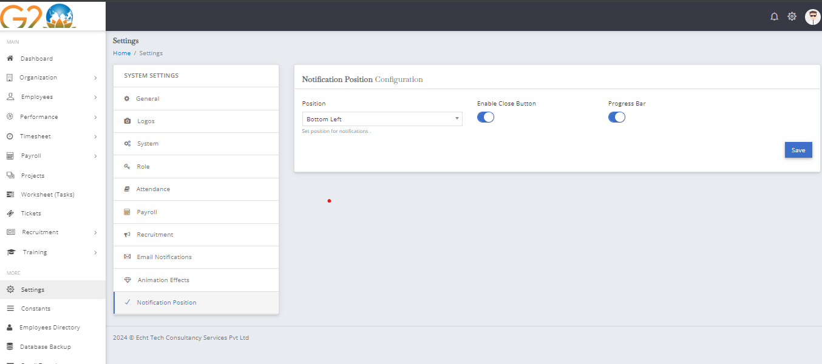

## **20.Payroll**

### **Description:**

This section is for setting the company logo on payslips. Users can upload the company logo through a file input field.

### **Form Fields:**

* Logo: File input field for uploading the company logo
* Save: Button to save the uploaded logo for payroll

## **Reference screenshot**

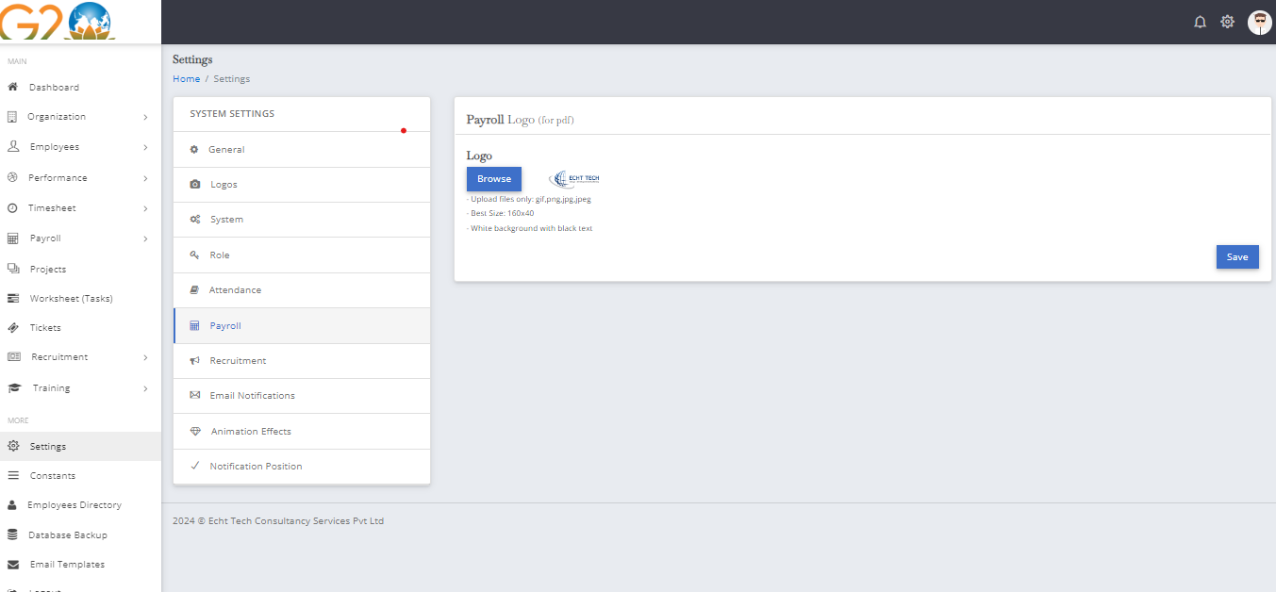

## **21.Recruitment**

### **Description:**

This section allows users to configure recruitment settings, including enabling jobs for employees and specifying acceptable job application file formats.

### **Form Fields:**

* Enable Jobs for Employee: Toggle switch
* Job Application File Format: Taggable text input field for multiple file formats
* Save: Button to save the recruitment configuration

## **Reference screenshot**

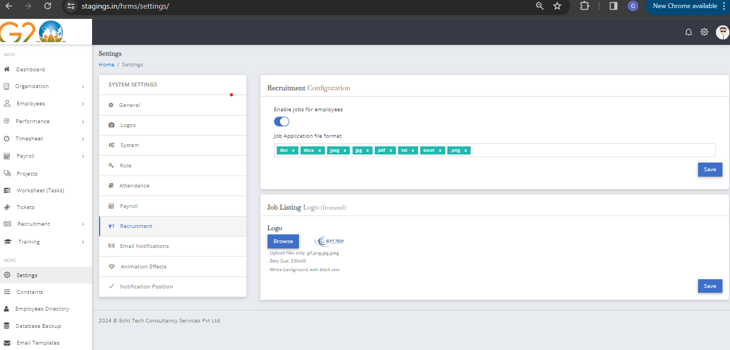

## **22.System Logos**

### **Description:**

This section includes two forms for adding logos. The first form is for adding the main logos, and the second form is for setting the sign-in page logo.

### **First Form Fields:**

* First Logo: File input field for the first logo
* Second Logo: File input field for the second logo
* Favicon: File input field for the favicon

### **Second Form Fields:**

* Sign-in Page Logo: File input field for setting the sign-in page logo

## **Reference screenshot**

